Bahria University,

Karachi Campus



LAB EXPERIMENT NO. _12_

LIST OF TASKS

|  |  |
| --- | --- |
| TASK NO | OBJECTIVE |
| Task 1 | Create a data structure to store a binary search. Implement a method to insert and search an element in BST. |
| Task 2 | Create a data structure to store a binary search. Implement a method to insert and traverse in BST (inorder, postorder, preorder). |
| Task 3 | N/A |
| Task 4 | N/A |
| Task 5 | N/A |
| Task 6 | N/A |
| Task 7 | N/A |
| Task 8 | N/A |

Submitted On:

__17/06/2020__

(Date: DD/MM/YY)

**Task No. 1:** Create a data structure to store a binary search. Implement a method to insert and search an element in BST.

**Coding:**

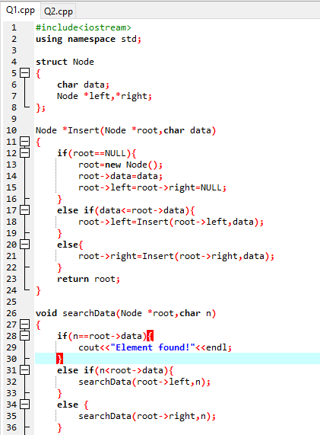

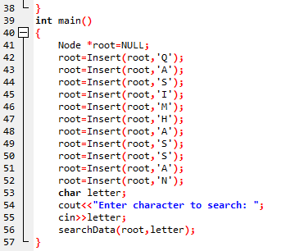

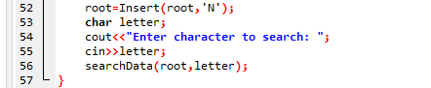

**Output:**

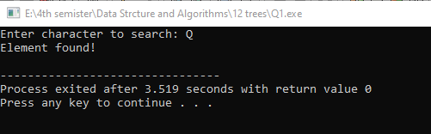

**Task No. 2:** Create a data structure to store a binary search. Implement a method to insert and traverse in BST (inorder, postorder, preorder).

**Coding:**

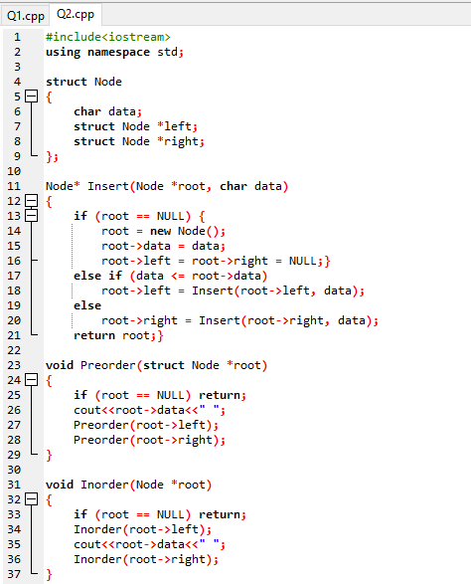

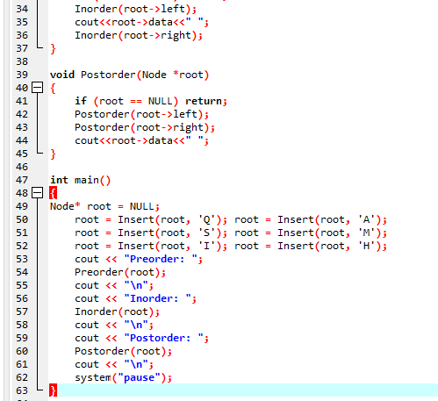

**Output:**

